ЗАДАНИЕ

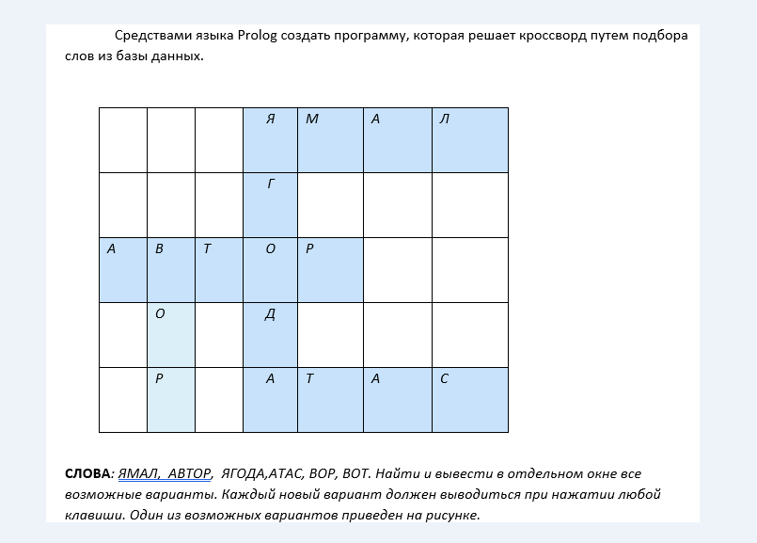

Решение

word(ямал, я,м,а,л).

word(автор, а,в,т,о,р).

word(ягодка, я,г,о,д,к,а).

word(атас, а,т,а,с).

word(вор, в,о,т).

word(вот, в,о,т).

crossword(V1,V2,V3,H1,H2,H3):- word(V1, V11,V12,V13,V14,V15,V16,V17),

word(H1, H11,V12,H13,H14,H15,H16,H17),

word(H2, H21,V14,H23,H24,H25,H26,H27),

word(H3, H31,V16,H33,H34,H35,H36,H37),

word(V2, V21,V22,V23,V24,V25,V26,V27),

word(H1, H11,H12,H13,V22,H15,H16,H17),

word(H2, H21,H22,H23,V24,H25,H26,H27),

word(H3, H31,H32,H33,V26,H35,H36,H37),

word(V3, V31,V32,V33,V34,V35,V36,V37),

word(H1, H11,H12,H13,H14,H15,V32,H17),

word(H2, H21,H22,H23,H24,H25,V34,H27),

word(H3, H31,H23,H33,H34,H35,V36,H37).